Download:

1. Retropie
2. Etcher
3. ROMS: http://www.completeroms.com/

Extract ROMS to .nes files, load it into NES folder in retropie/roms/nes

What you will need:

1. Power Supply (for raspberry pi)
2. Raspberry Pi
3. Display (Either 7” RPI display or a HDMI Display)
4. Thumb drive
5. SD Card
6. Keyboard
7. Crimp Heads
8. Crimper
9. Multicore Wire
10. Female Housing Connector
11. Soldering Iron
12. Solder Lead
13. Wire Stripper
14. Joystick
15. Buttons

Wiring up the joystick

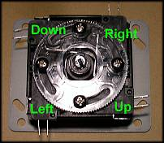

*8 direction digital Joystick*

Note, each pair of legs as shown is a mechanical connection. Take one of each pair (in our case, we took the right angled ones), connect them together, that would be connected to ground.

The others will be connected to the RPI GPIO pins as LEFT, RIGHT, UP, DOWN pins

Setting up the Joystick and Buttons

* Joystick UP:  **GPIO10**
* Joystick DOWN: **GPIO17**
* Joystick LEFT:**GPIO25**
* Joystick RIGHT: **GPIO9**
* Button A (one contact): **GPIO23**
* Button B (one contz7----------act): **GPIO 24**
* Joystick Ground, Button A & B second contacts: **GND** (there’s a bunch of GND pins available)

Download and install retrogame

Hit F4

1. cd
2. curl -O https://raw.githubusercontent.com/adafruit/Raspberry-Pi-Installer-Scripts/master/retrogame.sh
3. sudo bash retrogame.sh

Setup using config option 2

Reboot

Head back into console (F4)

Edit pin configuration

sudo nano /boot/retrogame.cfg

Check that the configuration is indeed option 2 (ref next page), otherwise, edit.

Once you’re done editing, you’ll see at the bottom left a clue that says ^X for EXIT. Which means to press CTRL+X

It’ll prompt to save the modified buffer

Type Y

And hit Enter

It’ll say it wrote 30 Lines

Head back into emulationstation to test out the joystick config

### Notes & Observations

Configuration remains unchanged during the setup of retrogame

Manual configuration following this file required

<https://github.com/adafruit/Adafruit-Retrogame/blob/master/configs/retrogame.cfg.2button>

# Sample configuration file for retrogame.

# Really minimal syntax, typically two elements per line w/space delimiter:

# 1) a key name (from keyTable.h; shortened from /usr/include/linux/input.h).

# 2) a GPIO pin number; when grounded, will simulate corresponding keypress.

# Uses Broadcom pin numbers for GPIO.

# If first element is GND, the corresponding pin (or pins, multiple can be

# given) is a LOW-level output; an extra ground pin for connecting buttons.

# A '#' character indicates a comment to end-of-line.

# File can be edited "live," no need to restart retrogame!

# Here's a minimal config for the "Retro Gaming" guide,

# 4-way stick + 2 buttons; have keyboard handy for other functions.

LEFT 25

RIGHT 9

UP 10

DOWN 17

LEFTCTRL 23 # Left control key = 'A' button

LEFTALT 24 # Left alt key = 'B' button

ESC 23 24 # Esc key = hold 'A'+'B' buttons (exit ROM)

SPACE 6 # Select

ENTER 5 # Start

# For configurations with few buttons (e.g. Cupcade), a key can be followed

# by multiple pin numbers. When those pins are all held for a few seconds,

# this will generate the corresponding keypress (e.g. ESC to exit ROM).

# Only ONE such combo is supported within the file though; later entries

# will override earlier.

**Joystick works at this point. Buttons do not work.**

At this point in time, the rules are there, the configuration is correct.

I found that going into the menu under retropie and configuring input works.

To skip keys and leave them as “not defined”, long press a key that is already taken.

To exit ROMS, Press and Hold A+B buttons (Essentially ESC key) together when its game over or at the game menu

ESC key does not work in-game

Pressing on the ‘Select’ button in game toggles game speed to slow, normal and fast

To access console from the emulationstation, hit F4

To get back into emulationstation, type emulationstation

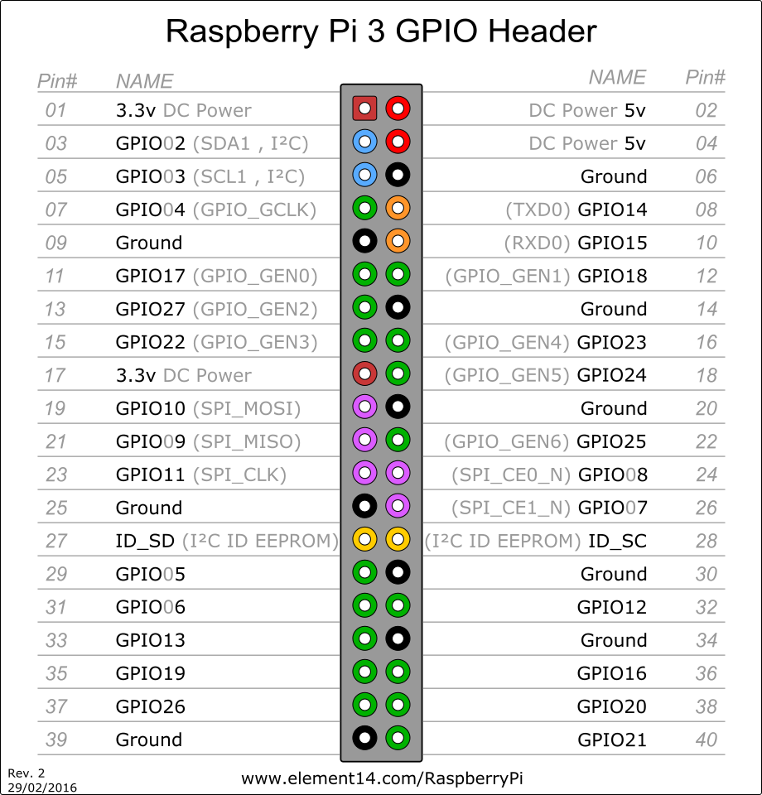

Adding in ROMS using a USB stick

# USB stick

1. (ensure that your USB is formatted to FAT32)
2. first create a folder called retropie on your USB stick
3. plug it into the pi and wait for it to finish blinking
4. pull the USB out and plug it into a computer
5. add the roms to their respective folders (in the retropie/roms folder)
6. plug it back into the raspberry pi
7. wait for it to finish blinking
8. refresh emulationstation by pressing F4, or choosing quit from the start menu

Hit F4, type sudo reboot